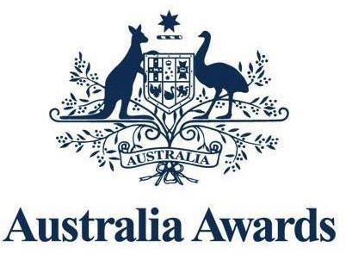
Australia Awards - Mongolia

English language requirements factsheet

English language proficiency is essential to succeed in post-graduate studies at Australian universities. For an Australia Awards Scholarship application to be eligible, a valid IELTS (Academic), or TOEFL-iBT, or PTE Academic certificate must be included.

Overall requirements

To meet eligibility requirements for an Australia Awards Scholarship, a valid English language proficiency test certificate (IELTS (Academic), TOEFL-iBT, or PTE Academic) must be submitted with the online application. English language proficiency certificates are valid for two-years. Therefore, they must be dated no earlier than 1 January 2023.
Where an institution’s academic English language requirement is higher than DFAT’s requirement for the main course of study, the awardee must meet the institution’s requirement.
Note: No exemption from providing an English language proficiency certificate is given to those who gained tertiary qualifications abroad in English.
For further details about English language scores, see the Australia Awards Scholarships Policy Handbook (Section 2.4).

IELTS
Applicants require an IELTS (Academic) score of 6.0 (with no individual band score of less than 5.5), or an equivalent Official TOEFL-iBT, or PTE Academic score [see table below].
Applicants require an IELTS (Academic) overall score of at least 6.5 with no band score less than 6.0 to be accepted into courses at Australian universities.

TOEFL-iBT or PTE Academic

IELTS (Academic) equivalent for TOEFL-iBT and PTE Academic scores can be found in the table below.

 | IELTS | TOEFL-iBT | PTE
Listening | 5.5 | 17 | 43
Writing | 5.5 | 17 | 43
Reading | 5.5 | 18 | 43
Speaking | 5.5 | 20 | 43
Overall | 6.0 | 72 | 50
Applicants must meet the minimum requirement of the English language proficiency tests shown in this table to qualify to apply.
To be accepted into courses at Australian universities, applicants require TOEFL-iBT overall score of at least 84 (no band score less than 21) or PTE Academic score of 58 with no communicative skill score less than 50.
Note: Only IELTS (Academic) scores are accepted for Australia Awards applications. General IELTS, TOEFL Test Home Edition, and Institutional TOEFL scores are not accepted and submitting these will result in an ineligible application.

Preparatory program
Successful applicants will be required to attend:
- English Language Training
- Academic Preparation Program
- Course counselling
- Pre-departure briefing
- University’s Introductory Academic Program
- Other required preparatory study on arrival in Australia.
If selected, provisional awardees will be offered up to six-months of English language training in Mongolia. Provisional awardees who do not achieve IELTS 6.5 or equivalent by the end of the English language training will forfeit their scholarship.
This training prepares candidates to sit English language examination during or at the end of the training.
All successful awardees will be required to complete an Academic Preparation Program in Mongolia before mobilisation.
Note: English language testing is conducted in Ulaanbaatar by commercial entities not aligned to the Australia Awards - Mongolia program.

